3. SEQUENCE OPERATIONS AND SIGNAL ANALYSIS
Experiment 3.1 Addition and Multiplication of Two Sequences
CODE :
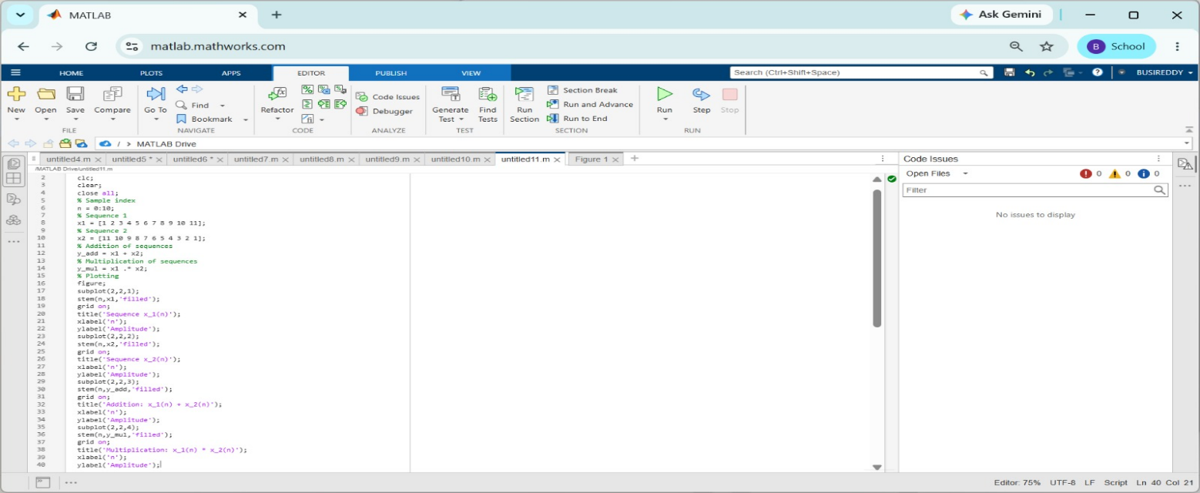
OUTPUT:
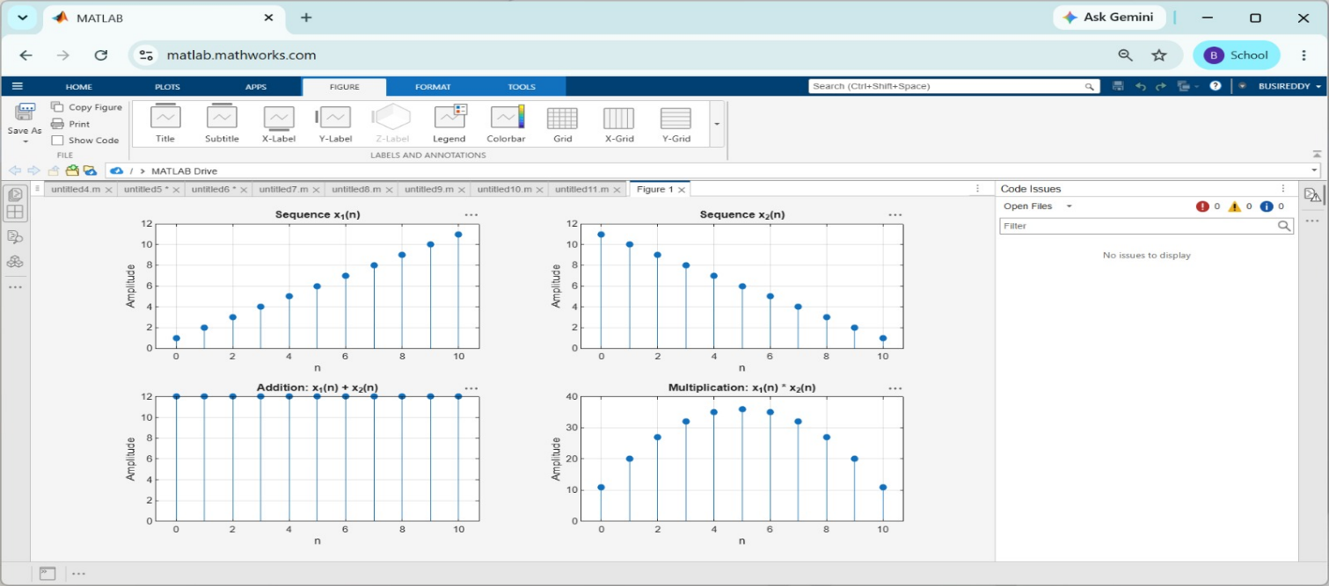
Experiment 3.2 Energy and Power Calculation of Given Signals
CODE:
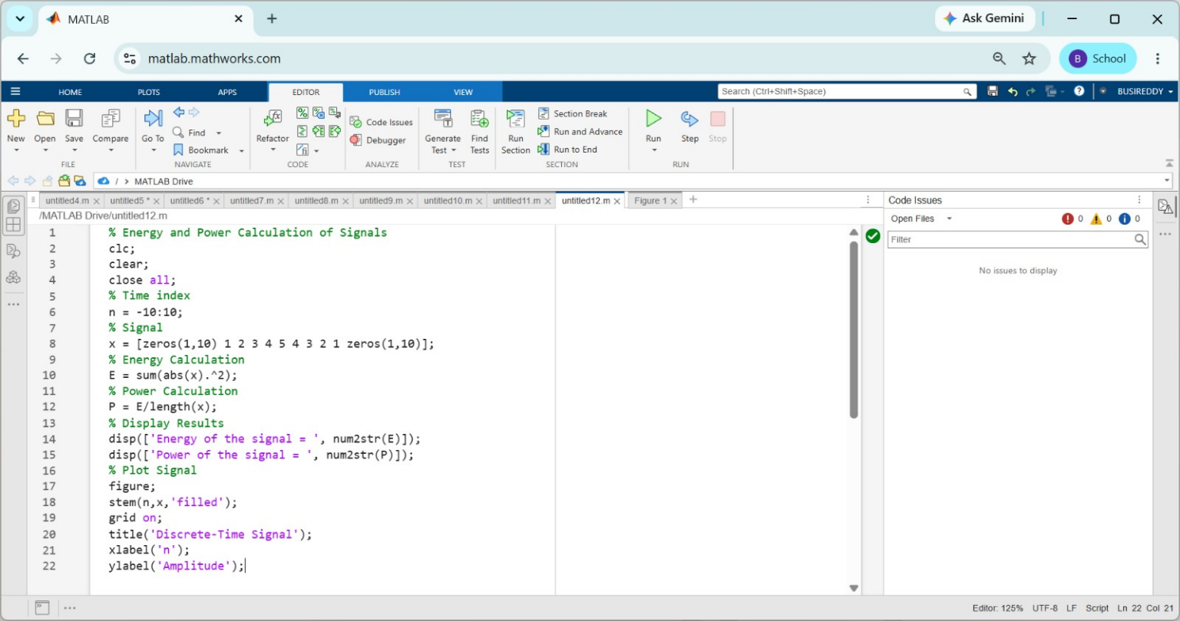
OUTPUT:
